Retail Logistics and E-Commerce Group Project

**ITLS6111 - Spatial Analysis**

Group Member:

Hongjin Gou 510332280

Dionisius Chaspuri - 520239252

# Executive Summary

## General introduction

COVID-19 has reached the endemic level phase, which means that the virus has its constant presence in the community (American Lung Association, 2022). However, during the great pandemic era of COVID-19, most retail sectors have been hit by the impact, especially during the lockdown period of 2020 - 2021, which forced some retailers to close their stores and move online. Post-lockdown has brought a new normal, bringing more foot traffic to major shopping centres and driving the reappearance of Bricks and Mortars stores.

This project will cover a retail chain with 25 offline shops and one online shop in the Australian Capital Territory (ACT) and New South Wales (NSW). The retail chain is considering closing two underperforming stores and opening one new store with a strategic location. While also ramping up online sales by 40% and offline stores by 15%. Furthermore, selecting the right distribution centres and routing planning are also considered to be this project's objectives.

## Analysis and Key Findings

By comparing sales of each shop in ACT, NSW and Rural Areas, a substantial difference in sales among all shops was identified. Most of the popular shops are located in Sydney, following rural areas and ACT stand the lower sales. The variance in sales among these shops might be attributed to geographical location, foot traffic, and local community lifestyle. For product types, consumers show clear popularity for health and beauty, while educational toys receive less attention.

By visualising the fluctuations in sales for different shops from 2022 to 2023, sales surges can be found in February, April and December, which could be linked to major holidays such as Valentine's Day, Easter, and Christmas.

In addition, we have also captured the popularity of each product type with visualisation tools. Health and beauty products attract higher sales, while educational toys receive less attention. The potential relationship between product type sales and overall sales is identified, hinting at location-specific demographics or strategies.

Through further analysis, such as regression modelling, we identified that an increase in the number of people who can drive to the store within 15 minutes and a rise in median income lead to higher sales. This may be associated with convenience and purchasing power. On the other hand, a higher population of the 0-4 age group could result in reduced sales. This potentially suggests that families with infants might cut back on spending to cater to their children.

In terms of selecting underperforming stores, we adopted score metrics consisting of various factors, including annual sales and monthly sales from December, as well as residuals from regression models. While past sales figures are important, we decided to incorporate residuals into the metrics as negative residuals may imply the actual performance is lower than the predicted sales, which can be considered a signal for poor performance. Location is another key factor we considered during the evaluation process. As analysed above, stores are more clustered in NSW, especially in the Greater Sydney region. To maximise market share and maintain brand visibility, it is reasonable to retain shops in regional areas and ACT where possible.

As for identifying locations for new shops, we opted for a multi-stage screening process where income, feasibility, and commercial suitability are all taken into consideration. We have also utilised the features identified previously and the regression model to predict sales in candidate locations, which are later used as the benchmark for final decision-making.

In terms of determining which distribution centre to choose, we first considered the ideal number of warehouses and came up with two warehouses. One warehouse around the Sydney CBD is picked using the location-allocation method. This method would help us find the most strategic warehouse location to cover all product replenishment for shops around CBD. In regards to the regional part, we use the service area method to find a warehouse location that could cover the replenishment for regional shops within a 5-hour drive buffer from the warehouse.

Lastly, with the routing optimisation, we use the vehicle routing planning method to consider which combination of fleets and how many trucks we need to completely replenish all 24 offline shops around NSW weekly. Further details will be outlined in the report below.

## Assumptions and Data Source

**Location Allocation**

1. The increase in the online shop’s sales quantities and remaining/new shop’s sales quantity: A 40% increase in sales quantities of the online shop and a 15% increase in sales quantities of the remaining/new shops were assumed when determining the weekly demand of all shops.

2. Order Distribution of the online shop: All orders made by customers on the online shop will be distributed equally to physical remaining/new shops for customers to pick up in person.

3. The size of the identified distribution centres: According to Fay (2021), the area size of a small distribution centre is usually more than 5,000 square metres. Thus, 5000 square metres was assumed as the area of each identified distribution centre when calculating the weekly rent of two identified distribution centres.

4. The speed limit of regional and CBD areas: The location-allocation approach was performed under the assumption of different speed limits of different areas. For CBD areas, the truck driver should not exceed 55 km/h; for regional areas, the truck driver should not exceed 100 km/h.

5. The regulated maximum driving time limit that truck drivers should comply with: The time that each truck driver spends daily/in a 24-hour period on driving should not exceed twelve hours, according to the Australian Standard Hours of Service Rule (Truckers Trip Planning App, n.d.).

6. Distribution centre opening time: The opening time of two identified distribution centres was assumed to be 5:00 AM to 5:00 PM.

**Vehicle Routing Plan**

1. Time limit per shift: The total time that each truck driver spends driving daily/in a 24-hour period can be divided into multiple shifts, and the driving time that each truck driver spends on each shift should not exceed 5.5 hours. In addition, each truck driver must take a break after a 5.5-hour shift, according to the Australian Standard Hours of Service Rule (Truckers Trip Planning App, n.d.).

2. Truck driver’s wage: According to Talent.com (2023), the hourly wage for a truck driver is around $34 per hour. Thus, a $34 hourly wage was assumed when calculating the wage per minute mentioned in the table under the ‘type of vehicles’ section.

3. The time windows for shops to accept deliveries: The time windows for shops to accept deliveries were assumed based on the area where the shops are located. For 2 shops in CBD areas, which are shop 219 and shop 246, deliveries can be accepted from 5:00 AM to 7:00 AM or 1:00 PM to 3:00 PM, whilst deliveries can be accepted only from 7:00 AM to 5:00 PM for shops in regional areas.

4. The earliest and latest starting time for the delivery: The earliest and latest starting time for the delivery were assumed as 5:00 AM and 10:00 PM, with the purpose of providing truck drivers with more time flexibility in terms of loading the trucks at the distribution centres. The delivery can only start at any time between 5:00 AM and 10:00 PM, but the delivery cannot start before 5:00 AM and after 10:00 PM.

5. Unit time: The unit time was assumed as 0.3 minutes per unit, which enabled the trucking loading time mentioned in Table 5 under the ‘Choice of Vehicles’ section to be calculated.

6. The Effective life of the trucks: According to the Australian Taxation Office (ATO, 2022), the effective life of trucks for warehousing and road transport is 15 years. Thus, 15 years was assumed as the length of the effective life of trucks, and it was also used for calculating the truck’s depreciation cost per day mentioned in Table 5 under the “Choice of Vehicles’ section.

7. U-turns: The sole situation in which a truck driver can make U-turns is assumed when performing vehicle routing problems on ArcMap. A truck driver can only make U-turns at intersections and dead ends. This assumption was made based on the fact that two identified distribution centres and physical shops are located in NSW and ACT, and the traffic rules and policies issued by the NSW Government (2023) and the ACT Government (Alexander, 2022). In general, in NSW and the ACT, U-turns are allowed at intersections unless there’s a sign indicating U-turns are prohibited.

8. The time windows for shops to accept deliveries should not be violated: Deliveries must adhere to the designated time windows to ensure they arrive at the shops within the acceptable delivery time frame.

9. The expected demand of shop 219 exceeds the maximum capacity of Articulated truck, which is the largest option among all types of trucks. We decided to split into 2 sub-stores to deliver.

**Data Source**

1. SA2_Australia_selected_medians_means_2021.W50S58K3.16416.17512.sr.lock (Digital Atlas of Australia, 2021)
2. SA2_Australia_SPCA_2021.W50S58K3.16416.17512.sr.lock (Digital Atlas of Australia, 2021)
3. SA2_Australia_SPCA_2021.W50S58K3.16416.rd.lock (Digital Atlas of Australia, 2021)
4. SA2_NSW_ACT_2016.W50S58K3.16416.17512.sr.lock (Digital Atlas of Australia, 2021)
5. SA2_NSW_ACT_socios_2016.W50S58K3.16416.17512.sr.lock (Digital Atlas of Australia, 2021)
6. RoadSegment_EPSG4283.gdb (NSW Government, 2020)
7. NSW_shops_location (University of Sydney, 2023)
8. AustralianCBD (University of Sydney, 2023)
9. SA2_Australia_SPCA_2021 (Census DataPacks, 2021)
10. SA2_Australia_selected_medians_means_2021 (Census DataPacks, 2021)

## Recommendations and Financial Implications

**Analysis of Sales Data and Benchmarking**

Based on the analysis, there is a clear indication of the significant impact of convenience and purchasing power on sales. Therefore, strategically positioning stores in areas optimised for both accessibility and income can be considered advantageous. Moreover, product and marketing strategies could be adjusted to cater more to households without young children or provide specialised offerings for families with infants to incentivise spending.

Based on the criteria discussed in Analysis and Key Findings, we identified two underperforming stores to be closed - shop 207 and 212. In addition, after considering the feasibility, location and profitability, we chose to open the new shop (shop number 526) at 5/26 Francis Forde Blvd, Forde ACT 2914. We believe this location would contribute to the market expansion to ACT and maximise market presence.

The corresponding annual sales for the two terminated shops are 2153 and 1070 units. By closing these two shops, sales performance will be negatively impacted. However, considering a new shop will be opened, and its predicted sales are 6330 units, which is significantly higher than the closing shops, the decision can be well justified by potential growth in overall revenue.

**Logistics and Distributions**

By performing the service area method and the location-allocation method, two distribution centres were identified, with the purpose of covering all physical shops and keeping the number of warehouses at the lowest possible level. Maintaining a warehouse quantity of two resulted in the lowest monthly distribution centre rental costs, amounting to $1,325,000.

Upon analysing the vehicle routing optimisation, it can clearly be seen that truck types can heavily influence the flow and efficiency of product deliveries. This statement is also supported by Interlane Logistics, saying that choosing the right truck for each delivery service is essential to ensure its product's safety and efficiency (Interlane Logistics, 2022). For instance, choosing the incorrect truck may result in a nonoptimal space usage per square metre, which may alter the number of units stored based on the maximum recommended truck capacity.

Based on the findings generated from the vehicle routing optimisation, it is suggested that purchasing eight articulated trucks and two small rigid truck would be the best financial decision as we focus our concern on delivery efficiency, fuel efficiency, and other variable cost. It will roughly cost $2,140,000 to purchase all ten trucks. However, the trucks will cover all the deliveries for 24 shops with a weekly fuel expense of only $3,818.

# Technical Report

# Analysis of Sales Data and Benchmarking

## 1.1 Exploratory Data Analysis of Historical Sales Performance (EDA)

The information for this project primarily stems from two datasets. One contains sales data from shops in NSW and ACT, inventory, sales, main product categories, and spatial data. The other dataset is from the 2021 Census of Population and Housing, which provides population statistics from various angles, such as gender ratios for different age groups and income levels in different regions. We have also derived additional data by conducting catchment analysis to calculate the population within the distance buffer and 15-30-minute service area to provide a more accurate representation of the SA2 population.

To ensure the quality of the analysis, it is crucial to conduct data cleaning first. From initial analysis, most missing data are observed in online shops. Due to the absence of specific spatial data, distributing the sales volume to other offline shops can not be justified for the purpose of benchmarking. As such, data for the online shop will not be considered further in sales analysis and will be removed from the dataset.

Data visualisation allows business users to identify relationships and patterns within the data, giving it deeper significance (Mou et al., 2023). Thus, we generated several graphs to depict the relationships of sales data and other features such as location, time period, and product type (Figure 1, 2, 3). The key findings associated with these graphs are detailed in the executive summary.

## 

*Figure 1. Sales and Shop Location Distribution*

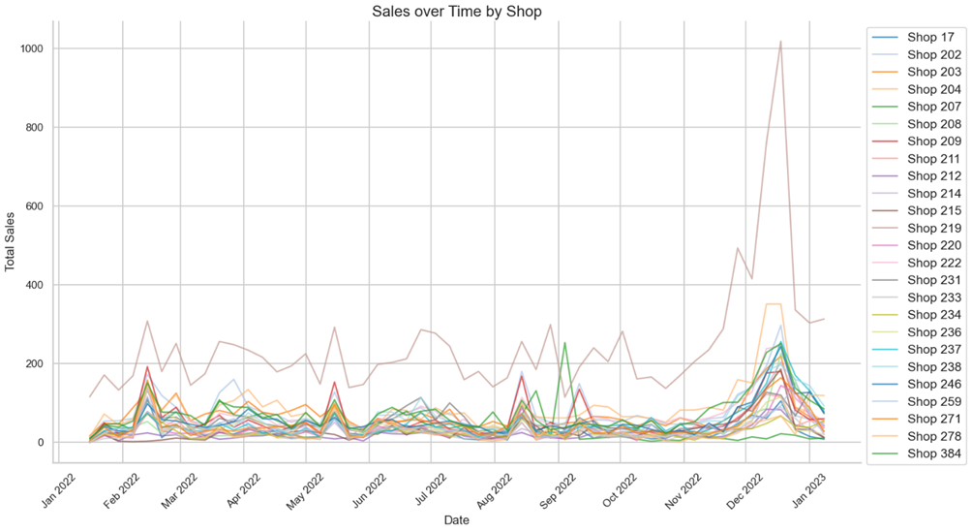

*Figure 2. Sales over Time by Shop*

## 

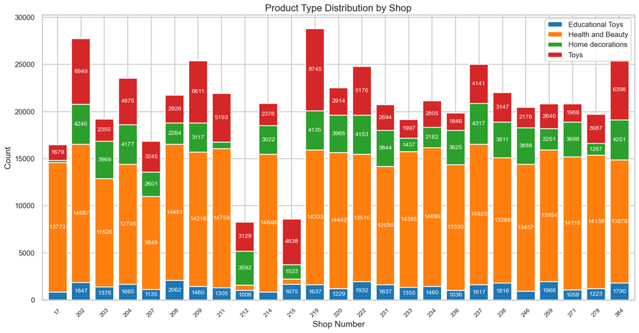

*Figure 3. Product Type Distribution by Shops*

## 1.2 Regression Modelling

**Product Type Regression Model**

Strong correlations are typically those above 0.6 (Nasiri et al., 2021). From Figure 4, we can conclude two primary factors strongly related to total sales are sales from toys and the median income level. Both these correlations are statistically significant, given their P-values are less than 0.05. The coefficient for median income is 0.0967, meaning for every unit increase in median income, there is a predicted 0.0967 unit rise in total sales, with other variables held constant. For toy sales, its coefficient of 0.6744 signifies that each unit increase in toys corresponds to a 0.6744 unit boost in total sales, assuming other factors remain the same. Therefore, both toy sales and median income play a crucial role in influencing overall sales. Additionally, the R-squared value of 0.705 indicates a reasonably good model fit, although approximately 29.5% of the variation in sales remains unexplained by the model.

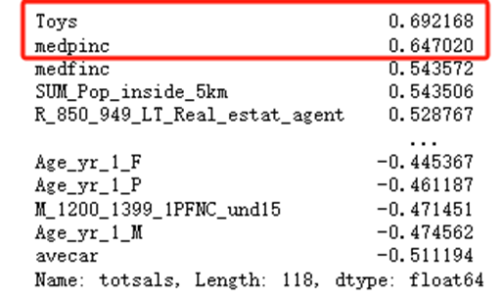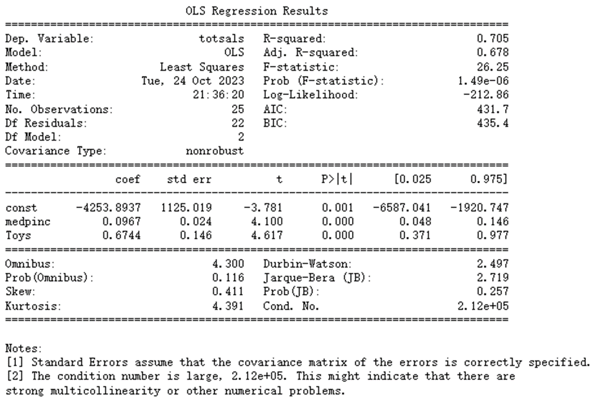

*Figure 4. Performance and Results of Product Type Regression OLS Model*

**Time Series Regression Model**

From a time series perspective, models can be established based on annual, quarterly, and monthly intervals. The advantage of this approach is the ability to predict sales more precisely within specific time frames (Zhang et al., 2017). However, the drawback is the reduced sample size, which might compromise the accuracy of models (Zhang et al., 2017). By segmenting based on time, aggregating sales and other features for specific periods can provide a more accurate depiction of business changes within those intervals. For instance, the fourth quarter sales would be the sum of the sales from October to December.

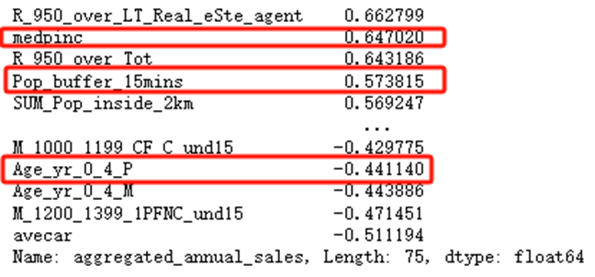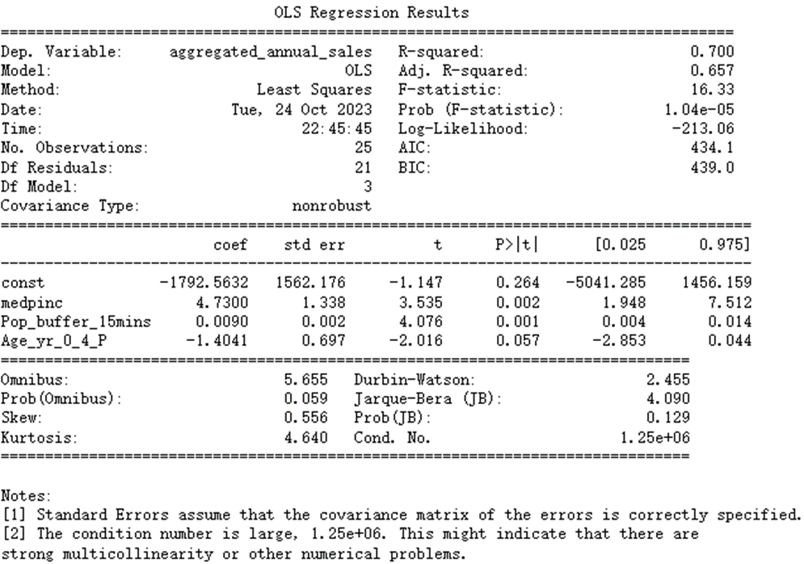

*Figure 5. Performance and Results of Annual Sales Regression OLS Model*

Figure 5 demonstrates that several factors play a significant role in determining aggregated annual sales. Median income, population within the 15-minute buffer, and population aged 0 - 4 exhibit a higher correlation, which may indicate a more significant impact on sales. We assumed features related to one's economic status, such as rent and car ownership, overlap with income. Thus, such features would be excluded from the regression modelling to avoid multicollinearity. Furthermore, the results corroborate the statistical significance of these correlations, with most variables presenting low P-values. The model possesses an R-squared value of 0.70, signifying it accounts for approximately 70% of the variability in the dataset.

To take the holiday season effect into consideration, we've integrated time dummies to assess the Christmas season's impact on quarterly and monthly sales. As illustrated in Figure 6, when examining quarterly versus monthly sales, it's evident that the median income and the population within a 15-minute buffer remain influential. The Fourth Quarter (Q4) and December dummies both have a P-value of 0, confirming their statistical significance. These models explain around 63% of the sales fluctuation, slightly less than the yearly model, yet still demonstrate significance in later benchmarking.

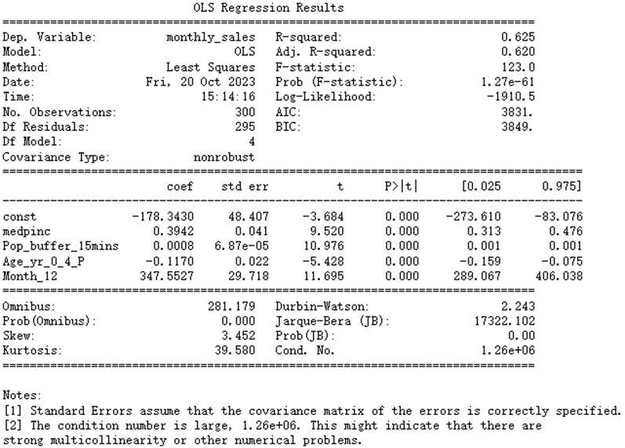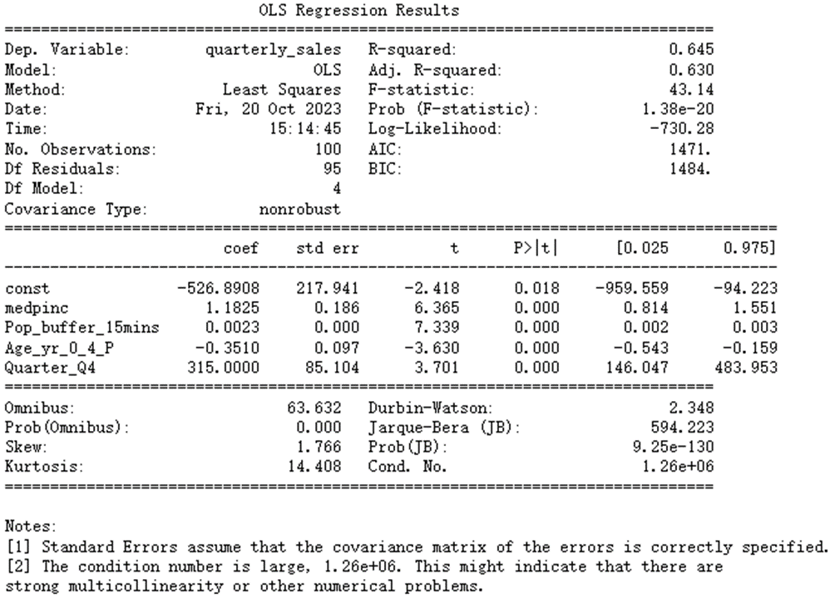

*Figure 6. Performance and results of quarterly and monthly sales regression OLS model*

## 1.3 Benchmarking and Selection of Stores to Close

The methodology employed for the selection of underperforming shops includes a comprehensive assessment of actual sales volume and the residuals generated by four regression models. In addition to these quantitative measures, the geographical location of the shops was also taken into account.

To perform objective store selection, we constructed a score metric by combining various features, as Table 1:

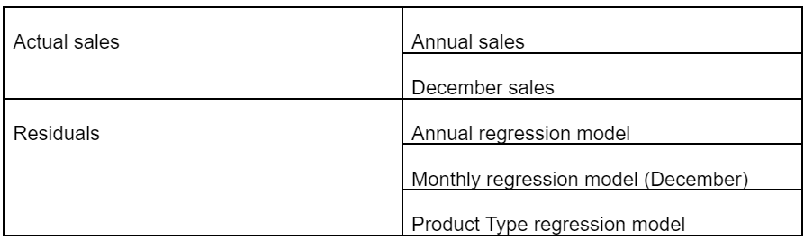

*Table 1. Features Selected for Score Metrics*

Notably, the residuals from the quarterly regression model were omitted from this metric due to its overlap with the monthly regression model, which could potentially lead to duplicate results.

Each shop was assessed based on the outlined score metrics. Each metric is ranked by value and given a score between 1 and 5, with a higher value signifying superior performance (Table 2). All metrics carried equal weight in the overall assessment. The collective findings are summarised in Table 1, with shops 207, 17, and 212 emerging as the weakest performers.

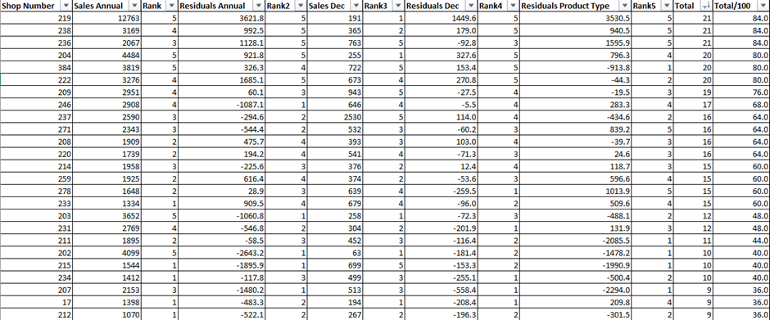

*Table 2. Score Metrics for Benchmarking*

However, upon a careful review of the geographic distribution of shop locations, we made a decision to retain shop 17 in the interest of maximising market coverage and preserving brand visibility despite its suboptimal performance. Consequently, it is our considered recommendation to close shops 207 and 212, which emerged as the most poorly performing establishments.

## 1.4 Location for New Shop

To determine suitable locations for opening new shops, we employed a multi-stage screening process. Firstly, we identified areas other than regions that have existing shops or intersect with the 15-minute buffer from existing shops. Subsequently, an initial screening of candidate regions was conducted, wherein income emerged as a crucial criterion due to its prominence in our regression models.

In the next step, we pinpointed the top 20 SA2 areas with the highest income. To further refine our selection, we utilised external tools such as Google Maps for a comprehensive assessment. Geographical features such as mountainous terrain, national reserves, or specific-purpose areas like military bases were eliminated from consideration. This process resulted in the shortlisting of 10 promising candidate regions (Table 3).

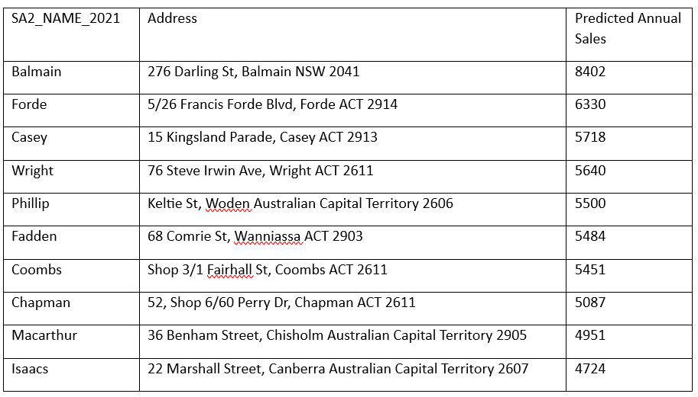

*Table 3. Candidate Shop Address and Predicted Sales*

With the selected regions in hand, we leveraged Google Maps to identify specific addresses suitable for commercial activities, such as shopping malls or areas with a concentration of retail businesses. Subsequently, we created 15-minute buffers around these locations and calculated the corresponding population figures. Combining income data and the population of the 0-4 age group, we ran the annual regression model to predict potential sales in these candidate locations.

The analysis from Table 3 indicates that a shop in Balmain would yield the highest sales. However, our maps revealed that the potential Balmain location is in close proximity to two existing shops. Consequently, we opted for the candidate location with the second-highest sales potential, which was identified in Forde, ACT (Figure 7). The new shop will be numbered 526 for future reference.

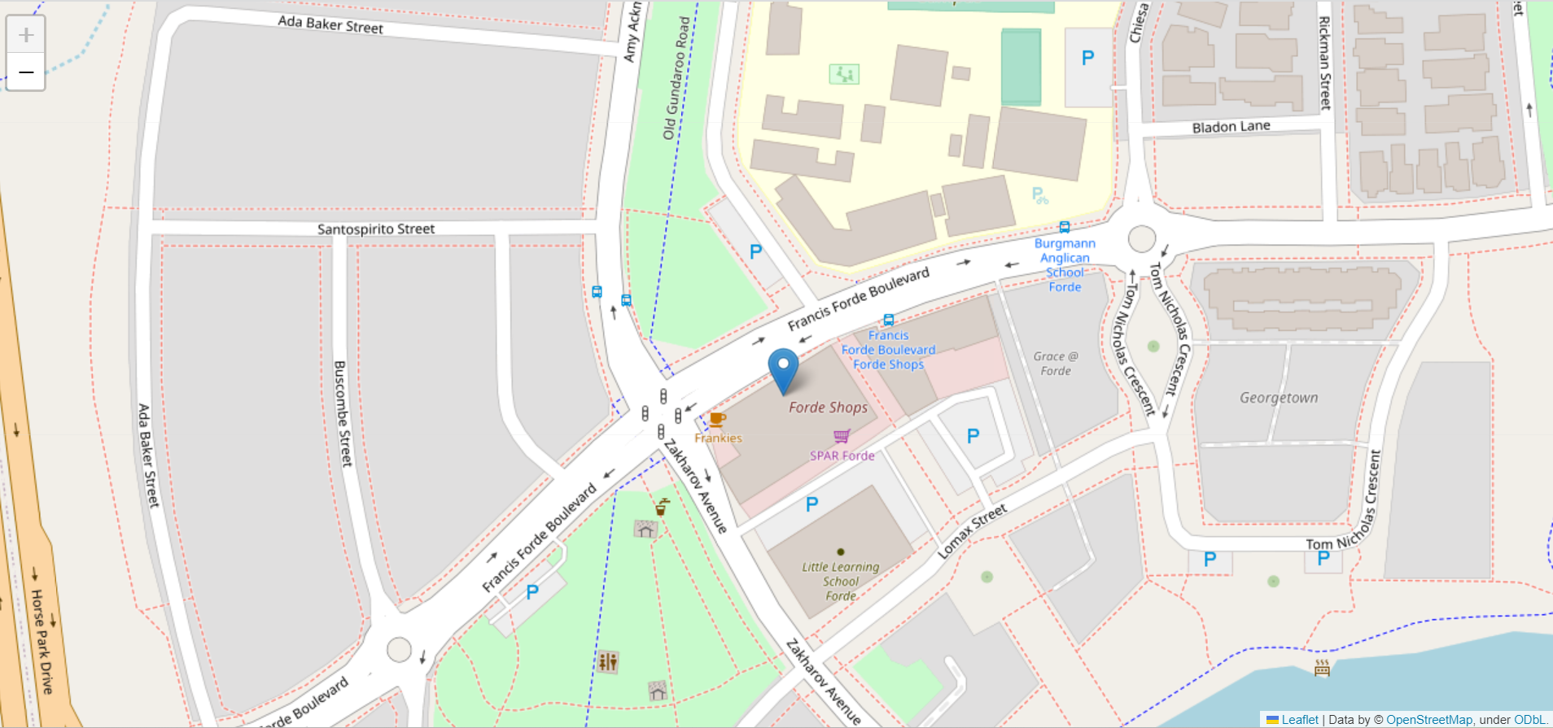

*Figure 7. Location of New Shop*

# Logistics and Distribution

## 2.1 Methodology

In our methodology, we harnessed the capabilities of ArcMap 10.8, employing advanced network analyst functions to guide our decision-making in Distribution Center (DC) selection, vehicle configuration, and routing optimization. Our approach was rooted in a data-driven analysis to achieve cost reduction and operational efficiency.

**Distribution centre selection criteria**

1. *Time Constraint Analysis*: We utilised the Service Area function to assess the geographic suitability of candidate DCs based on the assumptions of working policies for drivers.
2. *Location-Allocation Modelling*: We implemented this function, supported by ArcMap, to systematically evaluate candidate DC locations based on their capacity to meet shop demand and coverage of the geographical area.

**Vehicle selection and routing plan criteria**

1. *Capacity and Efficiency Assessment*: We considered the truck capacity, cost efficiency, and fuel efficiency of vehicle types.
2. *Vehicle Routing Problem VRP*: We applied the VRP function within ArcMap to determine the most efficient routes, sequence of deliveries, and allocation of vehicles, minimising overall delivery cost and ensuring timely while addressing the difficulties in various time windows and working restrictions of drivers.

## 2.2 Placement of Distribution Centers

Through our analysis, it became evident that the provided locations could not cover the shops in the ACT or the regional area, as the driving time from any of these DCs exceeded the 5.5-hour constraint. In our strategic planning, we have decided to consider one additional DC in a regional area of NSW to ensure comprehensive coverage while maintaining efficient and timely deliveries.

**Recommended locations for Distribution Centers**

From a pool of candidate locations, we have identified two strategically positioned sites:

*Distribution centre 1: Clunies Ross Street Greystanes NSW 2145*

* Rental Cost: $165 per square metre
* Located within NSW, this site offers efficient coverage to a substantial number of retail shops and is accessible via major transportation routes. The competitive rental cost aligns with our cost-conscious approach.

*Distribution centre 2: 19 Marsden Street Boorowa NSW 2586*

* Rental Cost: $100 per square metre
* Situated in a regional area, this location complements our geographical coverage, serving retail shops in the ACT region. The lower rental cost, compared to other NSW locations, balances cost efficiency with accessibility to the ACT area.

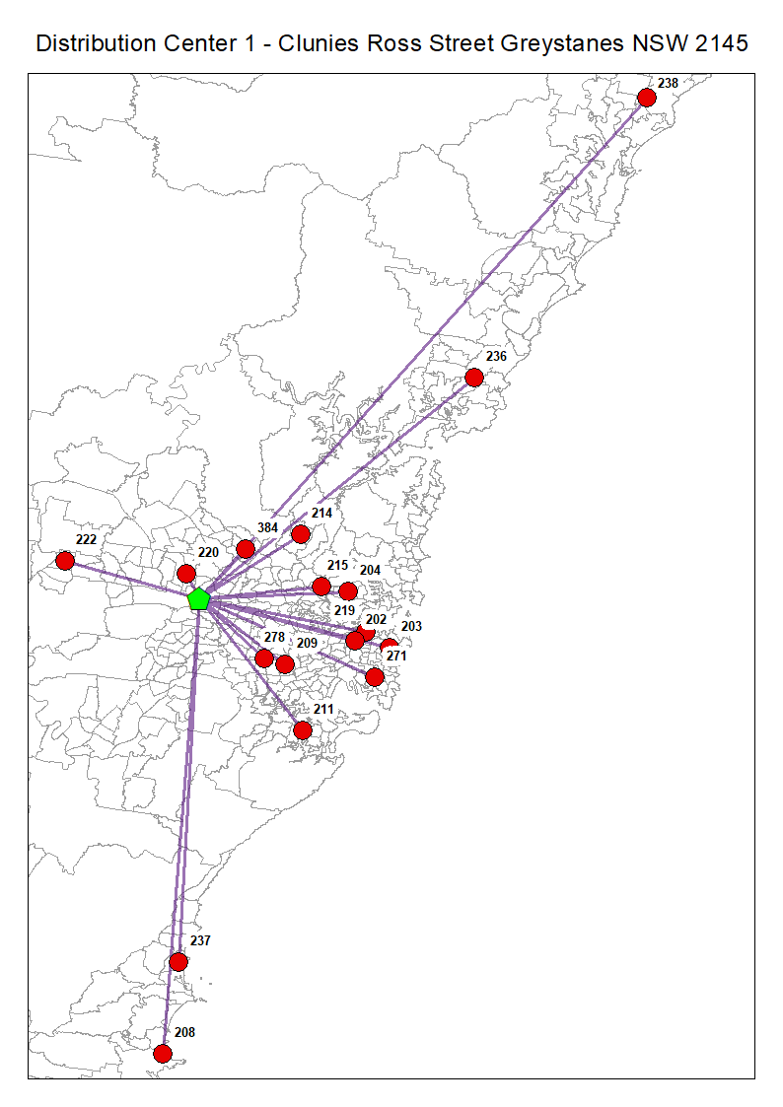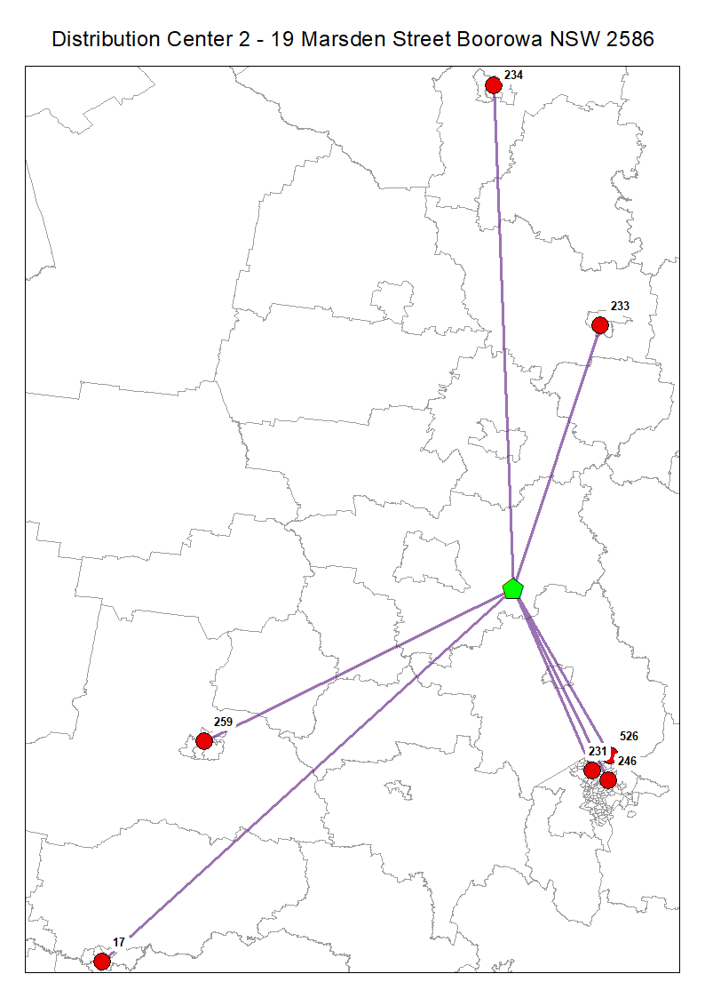

*Figure 8. Distribution Centre 1 Figure 9. Distribution Centre 2*

|  |  |  |  |
| --- | --- | --- | --- |
| **Distribution centre** | **Size** | **Rent / m2** | **Total rent** |
| Clunies Ross Street Greystanes NSW 2145 | 5000 m2 | $165 | $825000 |
| 19 Marsden Street Boorowa NSW 2586 | 5000 m2 | $100 | $500,000 |
| **Total rent per month** |  |  | $1,325,000 |

*Table 4. Weekly cost of distribution centres*

## 2.3 Routing plan

This section provides a detailed outline of our logistics and transportation plan for efficiently servicing retail shops across NSW and in ACT. The primary objective is to streamline our distribution operations in response to the changing retail landscape, including a 40% expected increase in online sales and a 15% increase in physical stores. By optimising our routing plan, we aim to ensure timely deliveries, cost-effectiveness and an environmentally responsive approach.

**Choice of vehicles**

To efficiently meet the evolving distribution demands, we will deploy a total of eight articulated vehicles, with six originating from Distribution Centre 1 (DC1) and two from Distribution Centre 2 (DC2). Additionally, we'll assign two small rigids from DC2. This selection optimises resource utilisation, reducing operational costs and environmental impact while accommodating the expected increase in demand.

Our choice of vehicle types aligns with the routing plan's requirements. Articulated vehicles, with their high capacity, are ideal for efficiently servicing a wide geographic area of retail shops. Large rigid vehicles are strategically assigned to DC1 where they can effectively serve high-demand shop specific retail shops. This selection balances capacity and efficiency, ensuring optimal distribution operations.

|  |  |  |  |  |  |  |  |  |  |
| --- | --- | --- | --- | --- | --- | --- | --- | --- | --- |
| **Truck type** | **Capacity** | **Loading time** | **Depreciation cost / day** | **Fuel cost/ km** | **Driver wage/ min** | **Qty** | **Total time (min)** | **Total distance** | **Total Cost** |
| **Articulated** | 250 | 75 min | $ 46 | $ 1.3 | $ 0.6 | 8 | 2239 | 1195 km | $ 3265 |
| **Small Rigid** | 40 | 12 min | $ 13 | $ 0.5 | $ 0.6 | 2 | 434 | 533 km | $ 553 |
| **Total** |  |  |  |  |  | **10** | **2673** | **1728 km** | **$ 3818** |

*Table 5. Weekly Cost of Trucks*

**Delivery schedule**

Our proposed delivery schedule is designed to align with the working hours of both the distribution centres (DCs) and retail shops. This approach not only optimises resource utilisation but also minimises waiting time, ultimately reducing drivers’ wages. The delivery schedule is set to be highly efficient and minimise disruption to retail shop operations. Deliveries are scheduled to take place on a weekly basis, exclusively on Tuesdays. This deliberate choice serves several important purposes:

Resource Consolidation: By concentrating deliveries on a specific day, we efficiently utilise our vehicles and driver workforce. This consolidation minimises operational costs while maintaining consistent service levels.

Reduced Disruption: The single-day delivery schedule minimises disruption to retail shop operations. Shop owners and staff can prepare for deliveries, ensuring a smooth and efficient process.

Environmental Responsibility: By reducing the number of delivery days, we contribute to lower emissions and environmental sustainability. Fewer trips mean less fuel consumption and a smaller carbon footprint.

| **No** | **Shop** | **Start 1** | **End 1** | **Start 2** | **End 2** | **Qty** | **Truck type** | **Arrive Time** | **Depart Time** |
| --- | --- | --- | --- | --- | --- | --- | --- | --- | --- |
| **1** | 17 | 7:00 | 17:00 | Null | Null | 33 | Articulated | 12:28 PM | 12:49 PM |
| **2** | 208 | 7:00 | 17:00 | Null | Null | 45 | Articulated | 10:21 AM | 10:44 AM |
| **3** | 215 | 7:00 | 17:00 | Null | Null | 37 | Articulated | 7:40 AM | 8:02 AM |
| **4** | 222 | 7:00 | 17:00 | Null | Null | 75 | Articulated | 7:50 AM | 8:22 AM |
| **5** | 233 | 7:00 | 17:00 | Null | Null | 32 | Small Rigid | 7:07 AM | 7:28 AM |
| **6** | 234 | 7:00 | 17:00 | Null | Null | 34 | Small Rigid | 9:25 AM | 9:46 AM |
| **7** | 237 | 7:00 | 17:00 | Null | Null | 60 | Articulated | 9:26 AM | 9:54 AM |
| **8** | 259 | 7:00 | 17:00 | Null | Null | 45 | Articulated | 10:31 AM | 10:55 AM |
| **9** | 278 | 7:00 | 17:00 | Null | Null | 39 | Articulated | 11:36 AM | 11:58 AM |
| **10** | 219(1) | 5:00 | 7:00 | 13:00 | 15:00 | 250 | Articulated | 6:53 AM | 8:20 AM |
| **11** | 219(2) | 5:00 | 7:00 | 13:00 | 15:00 | 35 | Articulated | 1:00 PM | 1:00 PM |
| **12** | 384 | 7:00 | 17:00 | Null | Null | 87 | Articulated | 7:00 AM | 7:34 AM |
| **13** | 202 | 7:00 | 17:00 | Null | Null | 93 | Articulated | 12:19 PM | 12:56 PM |
| **14** | 204 | 7:00 | 17:00 | Null | Null | 102 | Articulated | 8:09 AM | 8:48 AM |
| **15** | 238 | 7:00 | 17:00 | Null | Null | 73 | Articulated | 10:57 AM | 11:27 AM |
| **16** | 203 | 7:00 | 17:00 | Null | Null | 83 | Articulated | 1:07 PM | 1:41 PM |
| **17** | 209 | 7:00 | 17:00 | Null | Null | 68 | Articulated | 7:00 AM | 7:29 AM |
| **18** | 211 | 7:00 | 17:00 | Null | Null | 44 | Articulated | 7:49 AM | 8:12 AM |
| **19** | 220 | 7:00 | 17:00 | Null | Null | 41 | Articulated | 7:00 AM | 7:22 AM |
| **20** | 231 | 7:00 | 17:00 | Null | Null | 64 | Articulated | 7:32 AM | 8:00 AM |
| **21** | 271 | 7:00 | 17:00 | Null | Null | 54 | Articulated | 9:12 AM | 9:38 AM |
| **22** | 214 | 7:00 | 17:00 | Null | Null | 46 | Articulated | 7:00 AM | 7:24 AM |
| **23** | 236 | 7:00 | 17:00 | Null | Null | 48 | Articulated | 9:01 AM | 9:26 AM |
| **24** | 246 | 5:00 | 7:00 | 13:00 | 15:00 | 67 | Articulated | 1:00 PM | 1:29 PM |
| **25** | 526 | 7:00 | 17:00 | Null | Null | 142 | Articulated | 12:20 PM | 12:49 PM |

*Table 6. Weekly Delivery Schedule per Shop*

|  |  |  |  |  |  |  |
| --- | --- | --- | --- | --- | --- | --- |
| **Route** | **Name** | **Total distance** | **Origin** | **Destination** | **Start Time** | **End Time** |
| **1** | Articulated | 33 km | DC 1 | Shop 220 - 222 | 5:37 AM | 8:22 AM |
| **2** | Articulated | 138 km | DC 1 | Shop 209 - 211 - 237 - 208 | 5:14 AM | 10:44 AM |
| **3** | Articulated | 180 km | DC 1 | Shop 384 - 236 - 238 | 5:26 AM | 11:27 AM |
| **4** | Articulated | 54 km | DC 1 | Shop 278 - 202 - 219 (1) | 9:55 AM | 1:41 PM |
| **5** | Articulated | 72 km | DC 1 | Shop 214 - 215 - 204 - 271 | 5:13 AM | 9:38 AM |
| **6** | Articulated | 36 km | DC 1 | Shop 219 (2) | 5:00 AM | 8:20 AM |
| **7** | Articulated | 146 km | DC 2 | Shop 526 - 246 | 9:48 AM | 1:29 PM |
| **8** | Articulated | 536 km | DC 2 | Shop 231 - 259 - 17 | 5:00 AM | 12:49 PM |
| **9** | Small Rigid | 193 km | DC 2 | Shop 233 | 5:00 AM | 7:28 AM |
| **10** | Small Rigid | 340 km | DC 2 | Shop 234 | 5:00 AM | 9:46 AM |

*Table 7. Detailed Routing Plan*

# 

# 

# 

# References

Alexander, R. (2022, Nonmember 25). *U-Turn Road Rules In ACT*. LTRENT. https://www.ltrent.com.au/blog/u-turn-road-rules-in-act/#:~:text=U%2DTurns%20At%20Intersections%20Without,an%20intersection%20without%20traffic%20lights

American Lung Association. (2022). *Epidemic, Pandemic and Endemic: What’s the Difference?* https://www.lung.org/blog/epidemic-pandemic-endemic-covid#:~:text=Pandemic%20vs%20Endemic&text=Though%20an%20endemic%20is%20a,easily%20prevent%20and%20treat%20it.

Australian Taxation Office. (2022). *Taxation Ruling TR 2022/1 Income tax: effective life of depreciating assets (applicable from 1 July 2022)*.<https://www.ato.gov.au/law/view/document?DocID=TXR%2FTR20221%2FNAT%2FATO%2F00002>

Census DataPacks. (2021). *Www.abs.gov.au*; Australian Bureau of Statistics. https://www.abs.gov.au/census/find-census-data/datapacks?release=2021&product=GCP&geography=SA2&header=S

Digital Atlas of Australia. (2023, June 9). *ABS Estimated resident population 2001–2021 by 2021 SA2 (Beta)*. Digital.atlas.gov.au; Geoscience Australia. https://digital.atlas.gov.au/datasets/faeff3744d02441e896ca704a141fe95_0/explore

Fay, P. (2021, October 26). The range of warehouse sizing is increasing in both Melbourne and Sydney markets says JLL. The Industrialist. https://www.theindustrialist.com.au/news/2021/10/26/range-warehouse-sizing-increasing-both-melbourne-and-sydney-markets-says-jll%C2%A0

Interlane Logistics. (2022). *Choosing The Right Truck: Which One Is Perfect For Your Freight?* https://shipinterlane.com/news/choosing-the-right-truck-which-one-is-perfect-for-your-freight/#:~:text=In%20conclusion%2C%20choosing%20the%20right,you%20make%20an%20informed%20decision.

Mou, H., Liu, L., & Xu, Y. (2023). Panel Data Visualization in R (panelView) and Stata (panelview). *Journal of Statistical Software*, 107(7). <https://doi.org/10.18637/jss.v107.i07>

Nasiri, A., Shafiee, N., & Zandi, R. (2021). Spatial analysis of factors influencing land subsidence using the OLS Model (Case Study: Fahlian Aquifer). Earth Science Informatics, 14(4), 2133–2144.<https://doi.org/10.1007/s12145-021-00688-1>

NSW Government. (2020, February 6). *NSW Transport Theme - Road Name Extent*. Nsw.gov.au; NSW Government. https://portal.spatial.nsw.gov.au/portal/home/item.html?id=d05fb8d70c4c42bd859e8b8cae60a387

NSW Government. (2023). *U-turns and three-point turns*.<https://www.nsw.gov.au/driving-boating-and-transport/roads-safety-and-rules/stopping-giving-way-turning/u-turns-three-point-turns#:~:text=You%20must%20not%20make%20a,or%20double%20unbroken%20dividing%20line>

Talent.com. (2023). Truck Driver average salary in Australia, 2023. https://au.talent.com/salary?job=truck+driver#:~:text=Find%20out%20what%20the%20average%20Truck%20Driver%20salary%20is&text=How%20much%20does%20a%20Truck,up%20to%20%2480%2C219%20per%20year

The University of Sydney. (2023). *Group Project Report [datasets]*. Business School, The University of Sydney Canvas. https://canvas.sydney.edu.au/courses/51840/assignments/459969

Truckers Trip Planning App. (n.d.). Australia Standard Hours of Service Rule. https://www.truckers-trip-planning-app.com/australian-standard-hos-rule

Zhang, A., Song, S., Wang, J., & Yu, P. S. (2017). Time series data cleaning: From anomaly detection to anomaly repairing. *Proceedings of the VLDB Endowment*, 10(10), 1046–1057. <https://doi.org/10.14778/3115404.3115410>

# Appendix A - Meeting minutes

|  |  |  |  |
| --- | --- | --- | --- |
| **Date** | 28 Sep | **Location** | Zoom |
| **Time** | 9pm | **Duration** | 1 hour |
| **Attendees** | All members | | |

**Points discussed:**

Data cleaning - Regression model (OLS - GWR), Benchmarking, Visualisation, Network analysis, Interpret regression result in R

**Actions:** Next meeting (2 Oct)

# 

**Meeting minutes**

|  |  |  |  |
| --- | --- | --- | --- |
| **Date** | 2 Oct | **Location** | In-person + Zoom |
| **Time** | 11am | **Duration** | 2 hours |
| **Attendees** | All members | | |

**Points discussed:**

Task assignment, analysis the assignment requirement, Data process, regression model, Attributes

**Actions:** Different models, R, Python, data analytics knowledge

**Meeting minutes**

|  |  |  |  |
| --- | --- | --- | --- |
| **Date** | Everyday | **Location** | Whatsapp group |
| **Time** |  | **Duration** |  |
| **Attendees** | All members | | |

**Points discussed:**

Regression model, Attributes, Correlation with different groups in SPCA

**Actions:** Try to find and involve more dataset

**Meeting minutes**

|  |  |  |  |
| --- | --- | --- | --- |
| **Date** | Everyday | **Location** | WhatsApp group |
| **Time** |  | **Duration** |  |
| **Attendees** | All members | | |

**Points discussed:**

Different with the correlation in the regression model, the R-squared is too high and too low

**Actions:** Try to find and involve more dataset

**Meeting minutes**

|  |  |  |  |
| --- | --- | --- | --- |
| **Date** | Everyday | **Location** | WhatsApp group |
| **Time** |  | **Duration** |  |
| **Attendees** | All members | | |

**Points discussed:**

The population of different groups in the regression model, benchmarking, criteria for assessing performance

**Actions:** Create different service areas of the shops (in distances and time)

**Meeting minutes**

|  |  |  |  |
| --- | --- | --- | --- |
| **Date** | Everyday | **Location** | WhatsApp group |
| **Time** |  | **Duration** |  |
| **Attendees** | All members | | |

**Points discussed:**

Location-Allocation, VRP, OD cost matrix

**Actions:** Refer to the online guidance of arcmap for network analyst, tutorial videos

**Meeting minutes**

|  |  |  |  |
| --- | --- | --- | --- |
| **Date** | Everyday | **Location** | Whatsapp group |
| **Time** |  | **Duration** |  |
| **Attendees** | All members | | |

**Points discussed:**

The result from VRP is not convincing, the cost is high and the fleet is large

**Actions:** Try different scenarios, reduce the size and calculate costs and include the demand of online shop to physical stores

**Meeting minutes**

|  |  |  |  |
| --- | --- | --- | --- |
| **Date** | 25 Oct | **Location** | ABS building |
| **Time** | 11am | **Duration** | 4 hours |
| **Attendees** | All members | | |

**Points discussed:**

The report, format

**Actions:** Adjust the content, finalise the work and recommendations